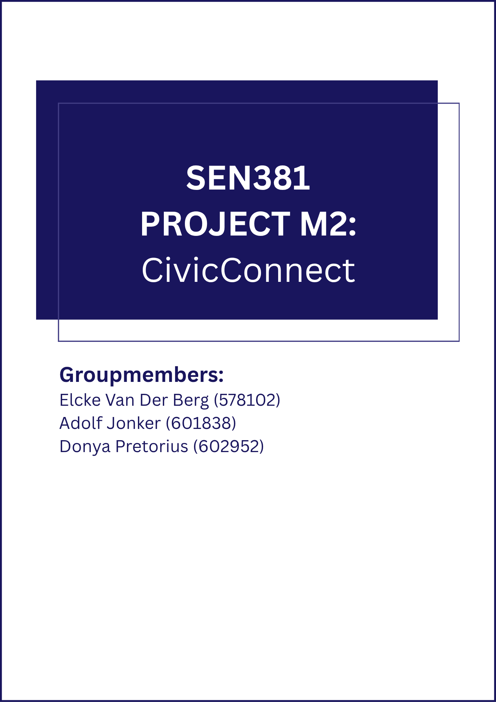
Table of Contents
Document Control 5
Problem & Business Need 5
Stakeholder Analysis 6
Meaningful conflicts / competing expectations: 6
Scope Baseline 7
In Scope 7
Out of Scope 7
Deferred / Future Scope 7
Defended Exclusion 7
Requirements & Acceptance Criteria 8
Functional Requirements (FRs) 8
Non-Functional Requirements (NFRs) 9
Constraints 10
Constraint Interaction and trade off 11
Section 5: Data and Persistence Baseline [Criterion C] 12
5.1 Entity Model 12
Relationships 12
5.2 Transaction & Concurrency Decision 13
Problem statement 13
Decision 13
ADR-DATA-001: Atomic Transaction and Optimistic Concurrency 14
5.3 Scalability and SPOF Notes 14
5.4 Access Patterns, Sensitivity and Growth 15
Access Patterns 15
Data Sensitivity 15
Growth Estimate 15
SPOF 16
Section 6: Design Decisions and Integrations [Criterion E] 17
6.1 Design Problem 1: Status Transition Management 17
Problem Statement 17
A2 Research Evidence 17
Final Judgement 17
Application Evidence 18
6.2 Design Problem 2: Role-Based Request Filtering 18
Problem Statement 18
A2 Research Evidence 19
Final Judgement 19
Application Evidence 20
6.3 Initial Integration Decision: In-Process Observer Seam 20
Context 20
Decision 20
Initial Requirements Traceability Matrix (RTM) 22
End to End Trace Example 24
Initial Risk Register 25
Forward Engineering Considerations 28
Engineering Decision Log 30
Team Working Agreement / Process Approach 32
1. Team Roles 32
2. Communication 32
3. Meeting Cadence 32
4. GitHub Workflow 32
5. Conflict Resolution 32
6. Accountability 33
7. AI Usage 33
GitHub Repository & Governance Controls 34
Repository 34
Branch Protection 34
Review & Approval Model 34
Commit & PR History as Evidence 35
AI Usage Register 36
Milestone 2 — Baseline Review & Initial Design Decisions 37
M1 Baseline Review — Controlled Change Check 37
ADR-DESIGN-001: Status Transition Guard + Observer for Audit Logging 37
ADR-DESIGN-002: Strategy-per-Role RBAC Filtering 38
Architecturally Significant Requirements and quality drivers 39
Measurable expectations used as architecture tests (not a second NFR list): 40
Architecture decision and diagrams 41
Alternatives compared 41
ADR-ARCH-001: Modular monolith (closes DEC-004) 41
Alternatives considered: 42
Context diagram (C4 Level1) 43
Container / component diagram (C4 Level 2–3) 44
Technology-stack decision 45
Comparison evidence 45
Selected stack — versions, licensing, compatibility 46
ADR-TECH-001: Technology stack (closes DEC-003) 47
Deployment compatibility 48
Current deployment direction 48
Compatibility with architecture and stack 49
Configuration, secrets, persistence, networking 49
Architecture, Technology & Initial Design Baseline — Sign-off(M2) 50
Team Sign-off (M2) 50
Historical M1 Baseline Sign-off 50
Bibliography 51

Document Control
Version | Date | Author(s) | Summary of Change
v1.0 | 09/09/2026 | Elcke Van Der Berg, Adolf Jonker, Donya Pretorius | M1 baseline: Problem & Business Need, Stakeholder Analysis, Scope Baseline, Requirements & Acceptance Criteria, initial RTM, Risk Register, Decision Log established and signed off.
v2.0 | 30/09/2026 | Elcke Van Der Berg, Adolf Jonker, Donya Pretorius | M2: architecture, data/persistence, technology and design-pattern decisions added; RTM Design Ref (M2) columns populated; controlled review of M1 baseline confirms no material changes required (see M1 Baseline Review below); implementation evidence linked.
Contributors this version: Elcke (PED/RTM continuity, design-pattern ADRs), Adolf (data/persistence, technology stack), Donya (ASRs/architecture, GitHub/CI evidence).
Review/Approval status: Accepted as M2 development baseline — see Architecture, Technology & Initial Design Baseline Sign-off.

Problem & Business Need

CivicConnect addresses the operational problems created by managing community service requests (facility faults, damaged equipment, security concerns, IT support, maintenance issues, lost property, and similar operational requests) through fragmented channels such as email, telephone, WhatsApp, spreadsheets and paper records.
The current process produces recurring failures: requests are duplicated, overlooked, incorrectly assigned or lost; requesters have little visibility of progress; staff struggle to prioritise and coordinate; accountability for status changes is weak; management lacks reliable information on outstanding, overdue and resolved work; reporting is manual and difficult to audit; and sensitive information is handled inconsistently across informal channels. No single controlled record tracks a request's lifecycle. Similar fragmentation and lack of structured tracking have been documented in IT service environments more broadly (Aglibar, et al., 2022; Smolle, 2025), reinforcing that this is a recognised organisational problem rather than one unique to this scenario.
The primary business value of CivicConnect is a single, controlled digital platform that provides a reliable, traceable and usable way to submit, manage, monitor and report on service requests. Value is realised through improved visibility and accountability for requesters, staff and management, not merely by the existence of a submission form. Every request carries a clear status, an identifiable owner and a complete history.

Stakeholder Analysis
Stakeholder | Core Need | Influence | Interest | What "Success" Looks Like to Them
Requester | Easy submission + visibility of request status | Low | High | Quick submission, clear status, timely resolution
Staff | Clear view of assigned work + low-friction status updates | Medium | High | Manageable workload, clear ownership, simple updates
Management/  Oversight | Reliable information on open/overdue/resolved work | High | High | Auditable data, trend visibility, decision support
Dev Team (the three of us) | A buildable, defensible, well-scoped system | Medium | High | Controlled scope, traceable requirements, defensible in defence
IT/Operations (future maintainer) | Maintainable system, low operational burden | Low | Medium | Manageable technical debt, clear documentation, sustainable cost

Meaningful conflicts / competing expectations:
- Speed vs. Structure — Requesters want to submit a request quickly with as little effort as possible, but Staff need enough detail up front to triage it properly. We addressed this with FR001 and NFR002.
- Transparency vs. Staff Workload — Requesters want to know what's happening with their request without having to ask, but Staff don't want to update status to turn into extra admin work on top of resolving requests. FR004 and NFR001 handle this by making status visibility automatic rather than something staff must manage separately.
- Reporting Depth vs. Scope Discipline — Management wants detailed reporting on outstanding and overdue work but building that properly would eat into the time we need for core requirements, traceability, and security evidence. We're only partially meeting this need with FR012's basic summary for now and deferring full reporting — see the Defended Exclusion below for the reasoning.

Scope Baseline

In Scope
- Requester: submit a request (FR001), view own request status (FR002), view own request history (FR003), receive status-change feedback (FR004).
- Staff: view relevant requests (FR005), search/filter/sort (FR006), view full details (FR007), assign/accept responsibility (FR008), controlled status transitions (FR009), record comments/resolution notes (FR010), resolve/close requests (FR011).
- Management: aggregate activity summary (FR012), filter by category/status (FR013).
- Role-based access control (NFR003).
- Complete, unaltered audit trail of status changes (NFR004).
- Core usability on desktop and common mobile browser widths (NFR005).

Out of Scope
- Advanced analytics/reporting (trend charts, exports, custom dashboards) beyond FR012's basic status-count summary.
- Multi-channel integration (auto-ingestion from WhatsApp, email or phone).
- Native mobile application (responsive web only).
- Automated request routing/AI-based categorisation or prioritisation.
- SLA breach automation (auto-escalation on overdue requests).
- Public-facing API for third-party integration.

Deferred / Future Scope
- Advanced management reporting and analytics (directly addresses stakeholder conflict #3).
- SLA-based automated escalation (NFR004 already captures the timestamps required; can be layered on later without rework).
- Multi-channel request ingestion (genuine pain point but exceeds schedule/cost/team-capability constraints for the educational project).

Defended Exclusion
Advanced analytics is deliberately excluded from the baseline despite Management's need for "reliable information about outstanding, overdue and resolved work."
Rationale: The Master Brief states additional features "do not automatically attract additional marks" and that "a smaller, controlled, high-quality solution may demonstrate stronger Software Engineering than a larger unfinished solution." Full analytics would add data-modelling, UI, testing and evidence obligations across every remaining milestone and would compete with the capacity required to deliver core traceability, security and quality evidence to a defensible standard.
Trade-off accepted: Management receives FR012's basic summary view (satisfying the minimum business capability), while richer analytics is recorded as deferred future scope. This preserves the option to add it later without making it a baseline commitment the team could fail to deliver.

Requirements & Acceptance Criteria

Functional Requirements (FRs)
ID | Requirement | Source | Priority | Acceptance Criteria
FR001 | Requester shall submit a new service request with title, description and a required category selected from a controlled list. | Requester capability; conflict #1 | High | Submission is rejected if category is missing; successful submission returns a unique request ID and confirmation.
FR002 | Requester shall view the status of any request they submitted. | Requester capability | High | Status (Open/Assigned/In Progress/Resolved/Closed) is retrievable within two navigation steps of login.
FR003 | Requester shall view a history/list of previously submitted requests. | Requester capability | Medium | List displays at least: request ID, category, date submitted, current status.
FR004 | Requester shall receive meaningful feedback when a request's status changes. | Requester capability; conflict #2 | High | Updated status is visible to the requester without requiring a manual refresh or enquiry to staff.
FR005 | Staff shall view service requests relevant to their authorised role. | Staff capability | High | List is filtered to the staff member's authorised scope.
FR006 | Staff shall search, filter or sort requests by status, category or date. | Staff capability | Medium | Filtering by status and category, and sorting by date, are available.
FR007 | Staff shall view full details of a specific request. | Staff capability | High | All submitted fields, status and action history are visible within two navigation steps of the request list.
FR008 | Staff shall assign or accept responsibility for a request. | Staff capability | High | Request is linked to exactly one responsible staff member; the assignment is visible.
FR009 | Staff shall update request status through defined, controlled transitions, per the following state model: Open → Assigned → In Progress → Resolved → Closed (Resolved and Closed are distinct, separately authorised steps — see FR011). | Staff capability; conflict #2 | High | Only transitions defined in the state model above are permitted; any attempt to skip a state (e.g. Open → Closed with no intervening action) is prevented or clearly flagged.
FR010 | Staff shall record comments or resolution notes on a request. | Staff capability | Medium | At least one comment/note can be attached and remains visible in the request history.
FR011 | Authorised staff shall resolve or close a request. | Staff capability | High | Only authorised staff can set the status to Resolved or Closed; Resolved and Closed are recorded as separate, sequential actions per FR009's state model.
FR012 | Management shall view an aggregate service activity summary (counts by status). | Management capability; conflict #3 | Medium | Summary displays counts of Open, Overdue, Resolved and Closed requests.
FR013 | Management shall view requests filtered by category, status or other justified dimension. | Management capability | Medium | Filtering by at least category and status is available.

Non-Functional Requirements (NFRs)
ID | Requirement | Source | Priority | Acceptance Criteria (Measurable)
NFR001 | Status changes shall become visible to the requester without a separate manual notification step. | Conflict #2 | High | Updated status is visible to the requester on the next page load or within 5 seconds of a staff action (whichever is sooner).
NFR002 | The minimal submission path shall require no more than six fields. | Conflict #1 | Medium | Field count on the minimal submission path ≤ 6.
NFR003 | The system shall restrict access to request data according to role (RBAC). Role-based access control is a long-established standard for managing access in networked systems (Sandhu, et al., 2000), and this project applies the same principle to restrict request data by role. | Security constraint (Master Brief §16) | High | A requester cannot retrieve another requester's data via the UI or by direct request.
NFR004 | The system shall retain a complete and unaltered history of status changes for each request. Tracking requirements, linking them to their sources, the evidence behind them, and associated downstream artefacts is recognised as a persistent challenge in software engineering (Mucha, et al., 2024), which is why this project includes a clear audit trail for all status changes. This non-functional requirement applies specifically to the audit history of each request, which is separate from the change-control process for the requirement baseline outlined in §11 of the Master Brief. | Traceability/  accountability need | High | Every status change is logged with timestamp and actor identity; the history is not editable or deletable through normal user actions.
NFR005 | Core submission and status-view functions shall remain usable on desktop and common mobile browser widths. Consistent, well-structured responsive interface design directly supports a sustainable and usable experience across devices (Li, et al., 2022). | Requester accessibility | Medium | Usable at 375px width without horizontal scrolling for the core submission and status-view flows.

Constraints
CivicConnect is created with a fixed scope, schedule, cost/resources, quality and security constraints. This is recorded in the table below. The engineering implications are also provided for later architecture and construction decisions so that boundaries are already considered instead of discovering them at a later state.
ID | Category | Constraint | Engineering Implication
CON001 | Scope | The set of requirements for milestone one (FR001-FR013, NFR001-NFR005) is fixed and controlled once they are agreed on. This means that any new feature cannot be added during the development project unless it follows the following formal approach: A request is made, the impact of the change is assessed, the change is then authorised, then it can be implemented, verified and the baseline is updated. | New feature requests cannot simply be added in without going through a documented impact analysis and must receive authorisation. This is done to protect the schedule and quality of the project as well as keeping a auditable baseline history which can be referred back to at later stages of the project.
CON002 | Schedule | The Project must be delivered over four fixed milestones with no time for rework or delays. | Forces defensible delivery. Deferred items such as SLA automation, multi channel ingestion are deliberately excluded now rather than be attempted under time pressure later.
CON003 | Cost / Resources | Team consists of three group members with limited combined team capabilities and experience. The project has no budget. Free or low cost services must be preferred where applicable and likely real world operating costs still need to be identified. | Technology choices at later stages will be limited to free or open source stacks. This limits load and scalability as well as rule out paid infrastructure level security tooling creating the need to add more security responsibility into the application layer.
CON004 | Quality | Quality attributes such as reliability of the audit trail and usability across devices must be explicitly defined upfront and later backed by measurable results such as test results, acceptance criteria met and quality gates passed. | Measurable acceptance criteria and visible evidence trail (RTM, Risk Register, Decision log) will be required so that quality can be demonstrated and proven rather than just simply being claimed at defence.
CON005 | Security | Security must be addressed at every stage in the project. This will include reviewing trust boundaries, authentication, authorisation, least privilege and an established access control principle (Sandhu, Ferraiolo & Kuhn, 2000). | RBAC (NFR003) and an immutable audit trail (NFR004) must be designed in as a authorisation/least privilege controls from the beginning and not added on at a later stage as an afterthought. Because of this the milestone 2 data model, access control and later ci/security checks will be directly shaped by this.

Constraint Interaction and trade off
In this baseline the most significant interaction is between the schedule (CON002) - Cost (CON003) and Quality (CON004) - Security (CON005). CivicConnect cannot deliver a fully featured system with rich management analytics and multi-channel request intake and still provide fully detailed defensible evidence of traceability, security and quality within the provided timeframe. This due to the fixed academic schedule and the three-person team constraints that limits the project. Because of this the team has chosen to focus on a smaller set of well-structured evidence and testable requirements (FR001-FR013, NFR001-NFR005) rather than a larger and less controlled feature set.
This is the same reasoning that was already recorded in the Scopes baseline defended exclusion where advanced analytics were deferred in favour of FR012's basic status count summary. The two are intentionally consistent and this can be seen by looking at the constraints section where the explanation for why the trade-off had to be made was due to a limited schedule and limited resources.
The second related trade-off is Cost vs Security. Because free-tier hosting and database services (CON003) are Preferred due to there being no budget. It is unlikely that these services will provide enterprise grade security features and infrastructure without the need for manually adding it to the Project. This puts a strain on the security of the project specifically for complying with RBAC (NFR003) and the audit trail integrity (NFR004) this Security concern will need to be integrated into the application layer which will be a direct constraint on the milestone 2 architecture and data model.

Section 5: Data and Persistence Baseline [Criterion C]

5.1 Entity Model
CivicConnect stores four main data entities. Their attributes, relationships and requirement links are shown in the table below.
Entity | Key Attributes | Notes | Req. Link
User | id, name, email, passwordHash, role (ENUM: Requester / Staff / Management) | Role drives which FilterStrategy is applied (Section 6.2) | NFR003, FR005
ServiceRequest | id, title, description, category (ENUM: Facility Fault / Damaged Equipment / Security Concern / IT Support / Maintenance / Lost Property / Other), status (ENUM: Open / Assigned / InProgress / Resolved / Closed), submittedById FK→User [N:1], assignedToId FK→User nullable [N:0..1], createdAt, updatedAt, version | version is the optimistic-concurrency counter; incremented on every update (see ADR-DATA-001). category is a database ENUM column on this table — not a separate entity (see Relationships note below). | FR001–FR013, NFR001, NFR004
StatusHistory | id, requestId FK→ServiceRequest [N:1], fromStatus, toStatus, changedById FK→User [N:1], timestamp, note (nullable) | Append-only; rows are never updated or deleted. Written by AuditLogObserver inside the same transaction as the status change. | NFR004, FR009, FR010
Comment | id, requestId FK→ServiceRequest [N:1], authorId FK→User [N:1], content, createdAt | Linked to a request; visible in the full-detail view. | FR010, FR007

Relationships
A User submits one or more ServiceRequests. This is a one-to-many relationship. A ServiceRequest may be assigned to one Staff User. This link is optional and nullable.
Each ServiceRequest has many StatusHistory records. A new record is written every time the status changes. These records are never changed or deleted. This is how the system meets NFR004 (immutable audit trail).
A ServiceRequest can also have many Comments. Staff write comments when handling a request (FR010).
Category is not a separate entity and does not appear in the entity table. It is a controlled ENUM column on ServiceRequest. The allowed values are Facility Fault, Damaged Equipment, Security Concern, IT Support, Maintenance, Lost Property, Other. A submission is rejected if the category field is missing or not on this list (FR001).

5.2 Transaction & Concurrency Decision

Problem statement
A status change touches two records. It updates the status on ServiceRequest and adds a new StatusHistory row. If only one write succeeds, the audit trail (NFR004) is broken. A history row for a change that never happened is just as wrong as a change with no history row. A second problem is concurrent updates. Two staff members could change the same request at the same time, either by assigning it (FR008) or by updating its status (FR009). Without a safeguard, the second update silently overwrites the first. The audit log would then be incomplete.

Decision
Every status change and assignment runs inside one database transaction. If any step fails, the whole transaction rolls back, and nothing is saved. ServiceRequest holds a version integer. The version covers every write to ServiceRequest, not only status changes. When staff loads a request, the current version is sent to their client. When they submit a change, the update checks that the version in the database still matches, and it adds 1 to the version. If another user changed the request first, zero rows are updated. The application then rolls back and asks the user to reload and try again. This is optimistic concurrency control.
The steps always run in this order:
Guard: StatusTransitionGuard checks that the transition is legal (FR009) and that the user is allowed to make it (FR011). If not, the change is rejected before any write.
Conditional update: ServiceRequest is updated WHERE id =? AND version=? and the version goes up by 1.
Row check: If zero rows were updated, the API returns HTTP 409 Conflict, and the transaction rolls back. The audit observer never runs, so no StatusHistory row is written.
Audit: Only after exactly one row is updated does AuditLogObserver write the StatusHistory row. This happens inside the same transaction.
Commit: Status, version, and history are saved together.
Notification: The requester notification (FR004) runs only after commit. If it fails, the status change stays saved, and the failure is logged.
Database constraints act as a backstop. A CHECK constraint (chk_request_status) limits ServiceRequest.status to the five valid values: Open, Assigned, InProgress, Resolved, and Closed.
This decision follows the A2 Task 2 research. A transaction makes related writes all-or-nothing. Optimistic concurrency assumes conflicts are rare, so an update only succeeds if the version is unchanged. Pessimistic locking was rejected because it holds the row until the first user finishes, which blocks other staff. Status updates are short, and conflicts are rare, so optimistic concurrency is simpler and enough.

ADR-DATA-001: Atomic Transaction and Optimistic Concurrency
Field | Content
ID | ADR-DATA-001
Status | Decided -M2
Context | Status changes must update ServiceRequest and write a StatusHistory row together (NFR004); concurrent staff updates, whether status or assignment, must not cause silent data loss.
Constraints | CON003: small team, free tools, so the design must stay simple. CON005: the audit trail must be designed in from the start.
Alternatives | 1) Pessimistic row locking: rejected, because it blocks other staff while a request is being edited. 2) Last write wins: rejected, because it silently loses updates. 3) Commit status first and write the audit later via an outbox (A2 Approach B): rejected, because the audit could lag and it needs extra infrastructure.
Decision | Wrap every status change and assignment in one transaction. Add a version integer to ServiceRequest that covers every write to it. Update with WHERE id = ? AND version = ?. Order: guard → conditional update → row check → audit observer → commit → notification. If zero rows are updated, roll back and return a conflict error. The audit observer does not run.
Trade-offs | Each update carries a small version-check overhead. Conflict errors return a 409 error and must be handled in the UI and show a "reload and try again" message. This is accepted because updates are infrequent and NFR004 correctness matters more than write speed.
Risks | Staff may see conflict errors on busy requests. Mitigation: a clear "reload and try again" message. A new code path could write to ServiceRequest without the version check. Mitigation: all writes go through ServiceRequestService, and PR review checks for it.
Evidence | A2 Task 2 (5.2–5.3): EdPrice-MSFT (2023a) on transactions; Databricks Staff (2026) on optimistic concurrency; Amazon Web Services (2025) on the outbox; OWASP (2019) on server-side validation. NFR004: history not editable or deletable by normal users.
Later consequence | Update at M3 with a concurrency test: two parallel updates on one request. One must fail with a conflict, and no extra StatusHistory row may appear.
RTM link | RTM-008 (FR008); RTM-009 (FR009); RTM-011 (FR011); RTM-017 (NFR004)
Related ADR | ADR-DESIGN-001 (Status Transition Guard + Observer)

5.3 Scalability and SPOF Notes
The database runs as a single instance. If it fails, the whole system is unavailable. This is a known single point of failure (SPOF). The team accepts this risk at M2. CON003 (no project budget) makes managed database replication or failover impractical. This risk is recorded in RISK-006.
The mitigation is to choose a free-tier platform that provides daily backups and point-in-time recovery. The team will confirm this feature is available on the selected platform before committing to it (FEC-003, FEC-004).
Free-tier hosting also limits the number of open database connections. The application will use a connection pool and stay within the limit documented by the platform. If load exceeds this limit, requests queue rather than fail immediately. Connection behaviour will be tested before deployment.
The Observer pattern (Section 6.1) keeps status notifications in-process at M2. This avoids adding an external message broker, which would be a second SPOF. The observer design allows notifications to be moved out of process later — without changing the core status logic or the transaction — when the system needs to scale (RISK-007).

5.4 Access Patterns, Sensitivity and Growth

Access Patterns
Three queries drive most database activity. The first is the request list query. It fetches ServiceRequests filtered by the logged-in user's role (FR005). This runs on every page load. It needs an index on submittedById for requesters and on assignedToId for staff. Without these indexes, the query scans every row in the table as the dataset grows. The second is the request detail query. It fetches one ServiceRequest and joins it with its StatusHistory rows and Comments. This runs when a user opens a request to read its full history (FR007, FR010). The third is the status update. It writes one ServiceRequest row and one StatusHistory row inside a single transaction (ADR-DATA-001). This runs far less often than reads. It is the write path that optimistic concurrency protects.

Data Sensitivity
User.email is personal information. It must not appear in list API responses or application log files. User.passwordHash must never be included in any API response. It is stored as a one-way hash and cannot be reversed. ServiceRequest descriptions may contain sensitive operational details, such as a report of a security concern. Role-filtered access through the Strategy pattern ensures that each user sees only the requests they are allowed to see (NFR003). StatusHistory rows record who changed a request's status and when (NFR004). Staff and Management can read the full audit trail, including the actor identity. Requesters get a restricted view of their own requests only. They see each status and its timestamp, but not the name of the staff member who made the change. This keeps FR002 and FR004 intact while limiting what staff identity data is shown to requesters.

Growth Estimate
CivicConnect targets a single campus. Expected load is hundreds to thousands of service requests per month. This is a small dataset. FR009 defines four forward transitions: Open → Assigned → In Progress → Resolved → Closed. A normal lifecycle therefore adds four StatusHistory rows per request, or five if the initial Open state is logged at creation. FR009 blocks or flags skipped states, so a flagged skip produces fewer rows, not more. FR011 keeps Resolved and Closed as separate steps, which is already counted above. The current state model has no reopen transition. If one is added later, the row count per request is no longer capped, but growth would still be small. Free-tier database storage is enough for this volume at M2. No partitioning or archiving strategy is needed at this milestone. The connection pool is sized to the free-tier limit of the hosting platform (RISK-006, FEC-003). If the campus expands to multiple sites in a later phase, this estimate must be reviewed.

SPOF
The single-instance database SPOF is documented and accepted in Section 5.3. The M2 design adds no other single points of failure. Because the Observer runs in-process, no external message broker or notification service sits in the critical path of a status change. RTM link: FR005 (RTM-005), FR007 (RTM-007), FR009 (RTM-009), FR010 (RTM-010), NFR003 (RTM-016), NFR004 (RTM-017).

Section 6: Design Decisions and Integrations [Criterion E]

6.1 Design Problem 1: Status Transition Management

Problem Statement
FR009 requires that status changes follow a fixed path: Open → Assigned → In Progress → Resolved → Closed. No step may be skipped. Invalid transitions must be blocked before they reach the database. When a status changes, two other parts of the system must react: the audit log must record the change (NFR004) and the requester must see the update without manually refreshing the page (NFR001). If all this logic lives inside one function, it becomes hard to test each part in isolation and hard to add new reactions later (for example, sending an email when a request is resolved).

A2 Research Evidence
Assignment 2, Task 1 researched how to manage status transitions. Two main options were found.
Option 1: switch-case / if-else chain. This is simple to write but becomes hard to change. Every new transition or new side effect requires editing the same block of code. This increases the chance of breaking existing behaviour.
Option 2: Observer pattern combined with a transition lookup table. The lookup table is a map from each status to the list of valid next statuses. It defines the rules in one place. The Observer pattern separates the status change from its side effects. When a status changes, the Subject (the transition service) notifies each registered Observer in turn. Each Observer handles one concern: audit logging, UI update, and so on. This makes each concern independently testable (Gamma et al., 1995; Chikkanayakanahalli Ramachandrappa, 2024).

Final Judgement
Our team chose Option 2: Observer pattern with a transition lookup table. The A2 recommendation matched the project need; it was adopted without modification. The transition lookup table enforces FR009 directly. Before any observer is notified, the service checks whether the requested transition is in the map. If it is not, the change is rejected. No state is written.
The ServiceRequestService acts as the Subject. Two observers are registered at M2. The AuditLogObserver writes the StatusHistory row inside the same transaction (ADR-DATA-001). The StatusVisibilityUpdater signals the UI layer to refresh the requester view (NFR001).
Trade-off: This adds an interface and an observer registration step that a simple function would not need. This overhead is small and accepted. The benefit is that each observer can be tested on its own. New observers, such as an email notification observer for RISK-007, can be added later without touching the transition logic or the transaction.

This decision is recorded in ADR-DESIGN-001 (see Milestone 2: Baseline Review)

Application Evidence
The following classes implement this decision.
- ServiceRequestService: Subject; holds the transitionRules map and the observer list; validates transitions before notifying observers.
- AuditLogObserver: writes a StatusHistory row inside the active transaction when notified.
- StatusVisibilityUpdater: signals the UI layer to refresh the requester's status view.
- transitionRules config: defines the map: Open→[Assigned], Assigned→[InProgress], InProgress→[Resolved], Resolved→[Closed].

6.2 Design Problem 2: Role-Based Request Filtering

Problem Statement
FR005 requires that each staff member sees only requests relevant to their role. NFR003 requires role-based access control (RBAC) for all data access. Three roles exist in CivicConnect: Requester, Staff, and Management. Each role needs different filtering logic when fetching the request list. If this logic is written as a chain of if-else statements inside the request-list endpoint, the code for all three roles sits in one place. Adding a new role or changing one role's logic means editing code that also controls the other roles. Each role cannot be tested in isolation.

A2 Research Evidence
Assignment 2, Task 1 also covered role-based filtering. Two options were compared.
Option 1: if-else chain inside the list endpoint. Simple to write but hard to extend. A new role requires editing existing code. Roles cannot be unit-tested independently. This approach violates the open-closed principle (Martin, 2000).
Option 2: Strategy pattern. A FilterStrategy interface defines one method: getFilteredRequests(userId). Each role has its own class that implements this interface. The list service selects the right strategy at runtime based on the logged-in user's role. This means each strategy can be tested on its own, and a new role only needs a new strategy class (Gamma et al., 1995; Six et al., 2022).
For category validation (FR001), the A2 research found that a simple membership check against a controlled list is sufficient. No pattern is needed. The valid categories are short and fixed.

Final Judgement
Our team adopted the Strategy pattern for role-based filtering. The A2 recommendation matched the project constraints. NFR003 is a high-priority security requirement, and RISK-003 (RBAC implemented incorrectly) is rated High impact. A testable, isolated design directly reduces this risk. Three strategy classes implement the FilterStrategy interface. RequesterFilterStrategy returns only the requests submitted by the logged-in user. StaffFilterStrategy returns requests assigned to or visible to that staff member. ManagementFilterStrategy returns all requests, supporting FR012 and FR013. Category validation uses a simple list check, as the A2 research recommended. No additional pattern is applied there.
Trade-off: Three strategy classes replace what could be one function. This is more code to maintain. The benefit is that each strategy is independently testable, which directly supports CON004 (quality must be demonstrated, not claimed) and reduces RISK-003.
This decision is recorded in ADR-DESIGN-002 (see Milestone 2: Baseline Review).

Application Evidence
The following classes implement this decision.
FilterStrategy: interface defining getFilteredRequests(userId).
RequesterFilterStrategy: returns requests where submittedById matches the logged-in user.
StaffFilterStrategy: returns requests assigned to or open for the staff member's scope.
ManagementFilterStrategy: returns all requests; no user-based filter applied.
RequestListService: injects the correct strategy based on session role; calls getFilteredRequests.

6.3 Initial Integration Decision: In-Process Observer Seam

Context
Implementation has reached the status-change boundary. The ServiceRequestService writes to the database and notifies its observers. This is the first meaningful interaction boundary in the system. The question is whether observers should call out-of-process services, such as an email or SMS API, at this stage. NFR001 requires that the requester sees status changes quickly. RISK-007 identifies notification delivery failure as a risk if the system depends on an external service.

Decision
At M2, all observers run in the same process as the application. No network calls are made when a status changes. The core transaction, updating ServiceRequest.status and writing the StatusHistory row, is never delayed by a notification attempt. The Observer pattern creates a natural seam. The ServiceRequestService does not know what its observers do. It only calls a notify method. This means a new ExternalNotificationObserver can be added later, registered alongside the existing observers, without changing ServiceRequestService or the transaction logic.
Keeping notifications in-process at M2 also means no external message broker can fail during a status change. The risk recorded in RISK-007 is therefore contained at this milestone.
Forward engineering: When out-of-process notification is needed (email or SMS), a new ExternalNotificationObserver class will implement the same observer interface. It will be registered in ServiceRequestService. No existing code changes. This is deferred and recorded as an update to FEC-005 (Observability & Notification).

ADR-INT-001 — In-Process Observer Seam for Status Notifications
ID | ADR-INT-001
Status | Decided - M2
Context | NFR001 requires that status changes are visible to the requester quickly. RISK-007 records the risk that an external notification service could fail during a status change. A2 API/integration research noted that a network boundary should only be introduced when the project genuinely needs it.
Alternatives considered | 1) In process only (chosen): zero external dependencies at this stage; no network latency or failure risk added to the core transaction. 2) External notification API (deferred): adds RISK-007 failure surface and requires secrets management; justified later when confirmed user need exists.
Decision | All observers are in process at M2. StatusVisibilityUpdater signals the UI layer directly. AuditLogObserver writes to the database in the same transaction. No external API, email service, or message broker is called.
Evidence | A2 Task 3 (API/integration research): in-process seam preferred until a real external boundary is needed. RISK-007: notification delivery failure. M1 FEC-005: observability/notification deferred.
Consequence | External notification (email, SMS) is deferred to a later milestone. A new ExternalNotificationObserver class will be added when needed. ServiceRequestService does not change.
RTM links | RTM-014 (NFR001); RISK-007; FEC-005 (updated)

Initial Requirements Traceability Matrix (RTM)
The RTM traces requirements from its originating stakeholder need or source through the requirements itself, to the acceptance criteria. The RTM is also structured so later evidence can be added without rebuilding it. The full expected chain of the RTM runs as follows, Stakeholder/Source -> requirements -> Design/Architecture -> issue/PR -> Implementation -> Test -> Acceptance/Release evidence. In the table below the Source, Requirements and Acceptance Criteria portions of the chain are established. Design and Test ref columns will only have the placeholder to be determined (TBD) for now as these columns will be filled in with Milestone two and three when design evidence and test evidence will be determined respectively. Once a requirement is a baseline it cannot be changed without an approved change record. Maintaining this structured traceability is a recognised consistent challenge in software engineering practice (Mucha, Kaufmann & Riehle, 2024), because of this The RTM will be treated as a live artefact from this milestone onwards.
RTM ID | Source | Req ID | Requirement (summary) | Priority | Acceptance Criteria (summary) | Design Ref (M2) | Implementation evidence | Verification evidence | Status | ADR / risk / change ref
RTM-001 | Requester stakeholder need: easy submission (Conflict #1) | FR001 | Submit request with title, description and required category | High | Rejected if category missing; successful submission returns unique request ID | Entity Model — category ENUM + validation (FR001) | No application source file is present in the supplied repository; implementation is documented only in Entity Model / Design Problem 2. | M3: automated submission/validation test; verify missing-category rejection and unique ID. | In Development | ADR-DESIGN-002; RISK-017
RTM-002 | Requester stakeholder need: visibility of status | FR002 | Requester can view status of any submitted request | High | Status retrievable within 2 navigation steps of login | ADR-ARCH-001 | No application source file supplied; documented design references requester status view. | M3: UI/integration test for requester status retrieval. | In Development | ADR-ARCH-001; RISK-013
RTM-003 | Requester stakeholder need: history of requests | FR003 | Requester can view history/list of previously submitted requests | Medium | List shows ID, category, date submitted, current status | ADR-ARCH-001 | No application source file supplied; request-list responsibility is documented. | M3: requester history/list acceptance test. | In Development | ADR-ARCH-001
RTM-004 | Requester stakeholder need (Conflict #2) | FR004 | Requester receives feedback when status changes | High | Updated status visible without manual refresh or enquiry to staff | ADR-DESIGN-001; ADR-INT-001 | No application source file supplied; StatusVisibilityUpdater is documented as intended application evidence. | M3: status-change visibility test; verify update after commit. | In Development | ADR-DESIGN-001; ADR-INT-001; RISK-007
RTM-005 | Staff stakeholder need: relevant workload view | FR005 | Staff can view requests relevant to their authorised role | High | List filtered to staff member’s authorised scope | ADR-DESIGN-002 | No application source file supplied; Strategy classes and RequestListService are documented, not verifiable as code. | M3: role-isolation tests for Requester/Staff/Management. | In Development | ADR-DESIGN-002; RISK-003; RISK-010
RTM-006 | Staff stakeholder need: manageable workload | FR006 | Staff can search, filter or sort requests | Medium | Filter by status/category and sort by date available | ADR-ARCH-001 | No application source file supplied; filtering responsibility is documented only. | M3: filtering/sorting acceptance tests. | In Development | ADR-ARCH-001
RTM-007 | Staff stakeholder need: clear ownership | FR007 | Staff can view full details of a specific request | High | All fields, status and action history visible within 2 steps of the list | ADR-DATA-001 (Access Patterns, Sec 5.4) | No application source file supplied; entity/access pattern is documented. | M3: detail-view acceptance test including status history and comments. | In Development | ADR-DATA-001
RTM-008 | Staff stakeholder need: clear ownership | FR008 | Staff can assign or accept responsibility for a request | High | Request linked to exactly one responsible staff member; assignment visible | ADR-DATA-001 | No application source file supplied; transactional assignment path is specified but not verified in code. | M3: assignment test plus concurrent-update test. | In Development | ADR-DATA-001; RISK-011; RISK-016
RTM-009 | Staff stakeholder need (Conflict #2) | FR009 | Staff update status via controlled transitions (Open→Assigned→In Progress→Resolved→Closed) | High | Only defined transitions permitted; skipped states prevented or flagged | ADR-DESIGN-001; ADR-DATA-001 | No application source file supplied; StatusTransitionService/transitionRules are documented design evidence only. | M3: valid/invalid transition tests and persistence/audit assertions. | In Development | ADR-DESIGN-001; ADR-DATA-001; RISK-012
RTM-010 | Staff stakeholder need: accountability | FR010 | Staff can record comments/resolution notes on a request | Medium | At least one note attached and visible in request history | Entity Model (Sec 5.1) | No application source file supplied; Comment entity is documented. | M3: comment creation and history visibility test. | In Development | Entity Model; RISK-015
RTM-011 | Staff stakeholder need: accountability | FR011 | Authorised staff can resolve or close a request | High | Only authorised staff set Resolved/Closed; recorded as separate sequential actions | ADR-DATA-001; ADR-DESIGN-001 | No application source file supplied; guard/transaction behaviour is documented, not verified in code. | M3: authorisation and sequential Resolved→Closed tests. | In Development | ADR-DATA-001; ADR-DESIGN-001
RTM-012 | Management stakeholder need: reliable oversight (Conflict #3) | FR012 | Management can view aggregate activity summary (counts by status) | Medium | Summary displays counts of Open, Overdue, Resolved, Closed | ADR-DESIGN-002 | No application source file supplied; management filtering/design responsibility is documented. | M3: summary count acceptance test against seeded data. | In Development | ADR-DESIGN-002
RTM-013 | Management stakeholder need: reliable oversight | FR013 | Management can filter requests by category, status or justified dimension | Medium | Filtering by at least category and status available | ADR-DESIGN-002 | No application source file supplied; management filter behaviour is documented only. | M3: category/status filter tests. | In Development | ADR-DESIGN-002; RISK-017
RTM-014 | (Conflict #2) transparency vs staff workload | NFR001 | Status changes visible to requester without a separate manual notification step | High | Visible on next page load or within 5 seconds of a staff action | ADR-DESIGN-001; ADR-INT-001 | No application source file supplied; in-process visibility seam is documented, not code-verified. | M3: timing/refresh verification after status commit. | In Development | ADR-DESIGN-001; ADR-INT-001; RISK-013
RTM-015 | (Conflict #1) speed vs structure | NFR002 | Minimal submission path requires no more than 6 fields | Medium | Field count on minimal path ≤ 6 | ADR-TECH-001 (React/Vite frontend) | No application source file supplied; frontend stack is documented but UI implementation is not verifiable. | M3: UI inspection/test confirming ≤6 fields. | In Development | ADR-TECH-001
RTM-016 | Lifecycle-wide security requirement: authorisation/least privilege (see CON005) | NFR003 | System restricts access to request data by role (RBAC) | High | A requester cannot retrieve another requester’s data via UI or direct request | ADR-DESIGN-002 | No application source file supplied; Strategy/RBAC design is documented but server-side enforcement is not code-verifiable. | M3: direct API and UI negative tests for cross-user access. | In Development | ADR-DESIGN-002; RISK-003; RISK-010
RTM-017 | Traceability/accountability need (CON005) | NFR004 | System retains complete, unaltered history of status changes | High | Every status change logged with timestamp and actor identity; not editable/deletable by normal users | ADR-DESIGN-001; ADR-DATA-001 | No application source file supplied; append-only StatusHistory and transactional observer are specified but not code-verified. | M3: audit-history integrity test plus concurrent-update test. | In Development | ADR-DATA-001; RISK-011; RISK-012
RTM-018 | Requester accessibility need | NFR005 | Core submission/status-view usable on desktop and common mobile widths | Medium | Usable at 375px width without horizontal scrolling for core flows | ADR-TECH-001 (ASR-05) | No application source file supplied; responsive frontend direction is documented only. | M3: 375px responsive acceptance check. | In Development | ADR-TECH-001

End to End Trace Example
FR001 traces from the source to acceptance criteria and illustrates how the RTM will extend through later milestones.
- Source: Requester stakeholders need for easy submission this further defined by Conflict #1 (Speed vs Structure) which is that requesters want minimal friction, staff need enough structured detail to triage.
- Requirement: (FR001) Requester will submit a new service request with a title, description and a required category selected from a controlled list.
- Supporting NFR: (NFR002) minimal submission path is six or fewer fields.
- Acceptance criteria: submission is rejected if the category is missing. A successful submission returns a unique request ID and confirmation.
- Current Status: baselined at milestone one, not yet designed or tested. At Milestone two this will gain a design reference and at milestone 3 it will gain a test reference.

Initial Risk Register
This register records the live project-specific risks carried forward from M1 and updated with M2 architecture, data, technology and implementation evidence. Each risk has a unique ID, description, cause, probability and impact rating, priority, mitigation, contingency, owner and status. The register is reviewed and updated at every milestone. M2 changes are focused on risks whose assumptions or mitigations were affected by the selected stack, persistence design, security design and the current evidence gap between documented design and application source.
No separate M1 “highest priority” statement is carried forward. RISK-001 and RISK-019 remain Critical scope risks; M2 also confirms RISK-006/RISK-014 as active hosting constraints and RISK-011 as an implementation-sensitive audit/concurrency risk.
Priority scale: Critical = must act now, High = act before next milestone, Medium = monitor and plan, Low = monitor
Risk ID | Description | Cause | Prob. | Impact | Priority | Mitigation | Contingency | Owner | Status
RISK-001 | Scope creep, stakeholders request new features after scope is baselined | No formal change process; stakeholders may assume the team can add features without impact | High | High | Critical | Maintain a controlled scope baseline from M1. All new requests go through a formal change request and impact analysis before acceptance. | Formally decline or defer the request. Record the decision in the Engineering Decision Log. Escalate to lecturer if unresolved. | Team Lead | Open
RISK-002 | Team member becomes unavailable for a significant period | Illness, academic pressure, or personal circumstances reducing a member's contribution | Medium | High | High | All members understand the full project, not only their own tasks. Shared code reviews and documentation reduce single-member dependency. | Redistribute work using the team working agreement. Log the variance. Notify the lecturer if a milestone deadline is at risk. | All | Open
RISK-003 | Role-Based Access Control (RBAC) implemented incorrectly | Access rules not clearly defined in requirements, or not tested per role | Medium | High | High | Define access rules per role (Requester, Staff, Management) in M1 requirements. Test each role in isolation during M3. | Restrict affected features to read-only or disable them. Log as a defect and apply a fix before any further testing or release. | Security lead | Mitigating
RISK-004 | Sensitive request data exposed through weak authentication or insecure endpoints | Security treated as a later concern; authentication not enforced on all data routes | Low | High | High | Security requirements defined in M1. All data endpoints require authentication. No secrets committed to the repository. | Disable affected features immediately. Apply and verify fix. Record incident in the Risk Register as a materialised risk. | All | Mitigating
RISK-005 | Team selects an unfamiliar technology stack, causing delays due to the learning curve | Stack chosen for interest rather than team readiness; learning time underestimated | Medium | Medium | Medium | Stack decision deferred to M2 with team capability assessment as a required input. Prefer tools the team has already used. | Reduce scope to core features. Record the schedule impact as a variance. Document the trade-off in the Decision Log. | Infrastructure lead | Mitigating
RISK-006 | Free-tier hosting or database limits reached, causing unexpected outage or cost | Platform limits not checked before selection; usage grows beyond the free tier during testing | Medium | Medium | Medium | Research and document free-tier limits for all candidate platforms in M2 decision records. Build within those limits. | Switch to a lower-cost alternative. Reduce data retention or feature scope as needed. Document the change. | Lead | Open
RISK-007 | Requester notification delivery fails; users do not receive status updates on their requests | Notification system not tested end-to-end; reliance on third-party email/SMS service without fallback | Medium | Medium | Medium | Define a notification NFR with a measurable acceptance criterion. Test delivery in staging before release. | Provide in-app status visibility as a fallback so requesters can still check their request. Log failures for review. | Developer | Open
RISK-008 | AI-generated artefacts (requirements, test cases, code) used without adequate human review | Time pressure; team trusts AI output without checking accuracy against project context | Medium | Medium | Medium | Every AI contribution is logged in the AI Usage Register. A team member reviews and verifies the output before it enters any controlled artefact. | Remove the unverified artefact. Replace with a human-authored version. Update the AI Usage Register to record what was rejected and why. | All | Open
RISK-009 | Duplicate or lost requests continue if staff bypass the system | Informal channels (WhatsApp/email) remain easier than the new tool | High | High | High | Make submission ≤6 fields (NFR002); train staff on a single channel; management uses FR012 from the system only. | Accept dual-running for a short period; log offline requests into the system daily. | Team Lead | Open
RISK-010 | Audit trail incomplete under concurrent staff updates | Race on status/assignment without version check | Medium | High | High | ADR-DATA-001 transaction + optimistic @Version; audit only after successful update. | Show conflict message; require reload. | Developer | Mitigating
RISK-011 | Illegal status skip (e.g. Open→Closed) breaks accountability | Missing guard or UI allows free status selection | Medium | High | High | StatusTransitionGuard + DB CHECK (ADR-DESIGN-001). | Reject write; flag attempt in logs. | Developer | Mitigating
RISK-012 | Assignment ownership unclear (two staff claim one request) | No single assignedTo enforcement | Medium | Medium | Medium | FR008: exactly one assignee; versioned update. | Conflict UI; manager reassigns. | Developer | Open
RISK-013 | Secrets committed or pasted into AI tools | AI/process slip (Master Brief §10) | Low | High | High | .gitignore; environment-variable-only secrets; AI register rules. | Rotate all exposed credentials immediately. | All | Open

Forward Engineering Considerations
These seven concerns are linked to current requirements and risks. FEC-001 is linked to RISK-003 and RISK-004 (security); FEC-002 is linked to NFR acceptance criteria in the requirements; FEC-003 is linked to RISK-006 (hosting limits) and DEC-003 (technology-stack decision); FEC-004 is linked to persistence design in M2; FEC-005 is linked to M3 release readiness; FEC-006 is linked to the performance NFR; FEC-007 is linked to DEC-004 (architecture decision).

ID | Concern | Why It Matters Now | Later Decision/Activity It Influences | Information Still Missing | Risk of Ignoring It
FEC-001 | Authentication & Authorisation | CivicConnect stores service requests that may contain sensitive data (e.g. security concerns, personal details). The system has three distinct user roles with different access rights. M2 has established the role-based access-control direction, but the access rules must be enforced consistently in the application and verified for each role. | M3 implementation and security testing. The chosen authentication and authorisation approach affects API structure, role enforcement, and access control throughout the system. | What personal data each role can access. Whether any single sign-on or external identity provider is required. | If ignored, access rules may be implemented inconsistently or bolted on late. This creates security gaps and requires rework across the application.
FEC-002 | Testability of Requirements | M3 requires automated tests traceable to requirements. The M2 RTM now includes implementation and verification evidence, but executable application tests are not evidenced in the supplied repository. Requirements therefore still need measurable acceptance criteria that can be mapped to actual tests. | M3 test strategy, test tooling, executable requirement verification, and CI pipeline. | Confirmation that all functional requirements have measurable acceptance criteria. Team agreement on what constitutes a passing test and the exact test locations once implementation begins. | If requirements are not testable, the team cannot produce credible quality evidence in M3. This affects both product verification and the assessment evidence.
FEC-003 | Deployment Environment & Hosting Limits | The project must stay within free or low-cost services. M2 has established the technology-stack direction, and M3 must validate that the selected stack can be deployed and operated within the available hosting limits. | M3 staging deployment and deployment-readiness verification. The selected stack must remain compatible with the available hosting environment. | The final hosting provider/account, exact free-tier limits, database retention/expiry rules, and confirmed connection/resource limits. | If the hosting environment is not confirmed and tested before M3 staging, deployment may fail late or require a rushed migration.
FEC-004 | Data Recovery & Request History Preservation | Service requests are operational records for the organisation. If data is lost due to a system failure, there is no paper backup to fall back on. M2 has defined the persistence and transaction approach, but backup and recovery arrangements still need to be established and evidenced. | M3 deployment preparation and M4 operational readiness review. Recovery procedures should be demonstrated before the system is treated as operationally ready. | How long request history must be retained. Whether the organisation has any existing data to migrate into the new system. What backup frequency and restore requirements are appropriate. | Without a backup or recovery strategy, a database failure could cause permanent loss of request records. This undermines the core business value of the system.
FEC-005 | Observability: Logging & Error Visibility | When the system is in use, errors will occur. Without appropriate logging, the team has no reliable way to determine what went wrong, where, or why. M2 has identified status-change and audit-related behaviour, but operational logging and failure visibility still need to be made explicit. | M3 release readiness and M4 operational evidence. The team needs to demonstrate how system failures, important events, and relevant status changes can be identified and investigated. | What events should be logged (errors, status changes, failed logins). Whether any logging service is available within the free-tier budget. | A production failure with no useful logs cannot be diagnosed quickly. This creates downtime and reduces accountability for what happened to service requests.
FEC-006 | Concurrent User Load & Performance | The system must handle multiple requesters submitting and checking requests while staff are updating statuses. M2 has identified transactional writes and optimistic concurrency as part of the data design, but the implementation and performance characteristics still need to be verified. | M3 concurrency and performance testing and later deployment readiness. Response-time expectations should guide implementation and verification. | The expected number of simultaneous users. Whether the selected free-tier hosting supports enough concurrent connections. The measurable response-time target to be used for testing. | If concurrency and performance are considered only after implementation, the architecture may already be difficult to change. Retrofitting scalability is harder than addressing the constraints during implementation.
FEC-007 | Maintainability & Code Structure | M2 has established the modular-monolith architecture, layering, and initial module structure. The remaining concern is ensuring that implementation follows the agreed structure consistently. | M3 implementation and the change-request process, followed by M4 technical-debt reflection. | The final implementation package/module structure and the team's detailed coding-standard evidence as the application is constructed.. | Code written without the agreed structure in M3 becomes harder to change in M4 and beyond. Technical debt introduced early reduces the team's ability to respond to the M3 change request.

Engineering Decision Log
This log records genuine engineering decisions made by the team across the project milestones. It distinguishes decisions that have been made from justified deferments where the required evidence does not yet exist. Decisions are supported by the relevant requirements, constraints, ADRs, risks, and engineering evidence, and their consequences are carried forward into later milestones.
ID | Type | Decision | Rationale | Trade-offs & Risks | Evidence & Later Consequence
DEC-001 | DECIDED | Define a controlled scope baseline at M1, explicit in-scope, out-of-scope, and deferred items. Context: The CivicConnect scope must be agreed and controlled before architecture and implementation work. | A vague scope cannot be changed formally. A controlled baseline makes change visible and manageable and provides the starting point for requirements and the RTM. | Trade-offs: Some features stakeholders may want are deferred. This is acceptable because scope discipline is a project requirement. Risks: Stakeholders may disagree with deferrals. Managed through the change-request process. | Evidence: Scope baseline section in PED v1.0. RISK-001 records scope creep as a managed risk. Later: Every change request is assessed against this baseline. M4 final success evaluation compares delivered scope with the approved baseline.
DEC-002 | DECIDED | Use GitHub with branch protection on main, requiring two approvals from team members other than the author before any merge. Context: The team needs a shared code and artefact repository with access controls supporting peer review and protection of the controlled baseline. | GitHub is explicitly referenced in the master brief and the team has existing familiarity. The two-reviewer approval model is an engineering control. | Trade-offs: Every merge requires two other team members to review, which can slow merges. Risks: Rubber-stamp approvals could defeat the control. Addressed through the meaningful-review standard. | Evidence: GitHub repository settings and protected main configuration. Later: This model continues through M2, M3 and M4 for substantive code, documentation and engineering artefact changes.
DEC-003 | DECIDED | Select Java 25 (LTS) + Spring Boot 4.1.x + Spring Security + React 19 / Vite + PostgreSQL 17 as the CivicConnect stack. See ADR-TECH-001. | Requirements and ASRs are sufficiently defined to evaluate the technology choices. Team capability and CON003 support a mainstream Java web stack with a Vite-built JS SPA. | Trade-offs: There is still a learning curve (RISK-005), and JVM free-tier memory remains a hosting consideration. Risks: Compatibility or environment-specific issues may require controlled engineering changes. | Evidence: ADR-TECH-001 records the technology selection and version pins. Later: The selected stack becomes the M2 technology baseline. Any material stack change requires a new ADR and supporting evidence.
DEC-004 | DECIDED | Adopt a modular monolith layered architecture. See ADR-ARCH-001. | ASRs for RBAC, audit and status visibility are best addressed within one application process under CON002/CON003. Microservices would introduce complexity without corresponding project evidence. | Trade-offs: A modular monolith reduces deployment complexity but requires discipline around internal module boundaries. Risks: Poor internal modularity could create coupling and technical debt. Mitigated through package boundaries and design ADRs. | Evidence: ADR-ARCH-001 and the M2 architecture/module documentation. Later: The architecture becomes the M2 baseline for implementation and is verified against the application structure during M3.
DEC-005 | DECIDED | Create and store a formal Team Working Agreement in the GitHub repository, reviewed and agreed by all three members. Context: The project requires a defined process for collaboration, disagreement resolution, work distribution and deadlines. | An informal agreement cannot be reliably evidenced. A documented agreement provides a reference point for resolving disputes and demonstrates a shared team process. | Trade-offs: Time is required to create and maintain the agreement. Risks: The agreement may not cover every situation. It should remain a living document and be updated where genuine process gaps emerge. | Evidence: Team Working Agreement committed to the repository with contributions from all three members. Later: Reviewed at each milestone gate; significant process changes are recorded as updates.

Team Working Agreement / Process Approach

1. Team Roles
Member | M1 Focus Area
Elcke Van Der Berg | Problem & Business Need, Stakeholder Analysis, Scope Baseline, Requirements & Acceptance Criteria, PED/RTM continuity, design-pattern ADRs.
Adolf Jonker | Constraints, Initial RTM, data/persistence, technology stack.
Donya Pretorius | Initial Risk Register, Forward Engineering Considerations, Engineering Decision Log, ASRs/architecture, GitHub/CI evidence

Roles will be reassessed each milestone as the project's focus shifts (e.g. toward architecture in M2, construction in M3). All three members remain individually accountable for the complete project regardless of section ownership, per the Master Brief's individual accountability standard (§8).

2. Communication
- Primary channel: WhatsApp
- Response expectation: within 5 hours on working days
- Check-in: Daily to review progress, blockers, and upcoming deadlines

3. Meeting Cadence
- Standing weekly check-in as above, increasing in frequency as milestone deadlines approach
- A full team review of the PED at least 48 hours before each milestone submission, covering all sections together — not just individual review of one's own part

4. GitHub Workflow
- All substantive changes are made on feature branches, never committed directly to main
- Every Pull Request requires a minimum of two approvals from team members other than the author; self-approval is not permitted
- Commits and Pull Requests are made progressively throughout each milestone, not batched immediately before a deadline
- Each Pull Request is linked to its corresponding project board issue (e.g. Closes #1) to maintain traceable evidence of who did what, and when

5. Conflict Resolution
- Disagreements on technical or content decisions are discussed as a team first, aiming for consensus
- If unresolved, the team proceeds by majority decision, with the disagreement and rationale recorded in the Engineering Decision Log
- Persistent conflicts affecting delivery are escalated to the lecturer early, rather than left to resolve themselves under deadline pressure

6. Accountability
- Each member is expected to understand the whole project, not only the section they personally authored — since any team member may be individually questioned on any artefact during the milestone defence
- Missed commitments or blockers are flagged to the team as soon as they arise, not discovered during final review

7. AI Usage
- Any material AI-assisted work is logged in the AI Usage Register, including what was verified, changed, or rejected
- AI-generated content is independently checked (facts, citations, requirement accuracy) before being accepted into any controlled artefact — per the Master Brief, "AI generated it" is never an acceptable engineering defence on its own

GitHub Repository & Governance Controls

Repository
The team uses a single controlled repository: https://github.com/AdolfJonker/SEN_381_Group_E.git

Branch Protection
The main branch is protected. Direct commits to main are not permitted for substantive changes; all changes must go through a Pull Request.

Review & Approval Model
A minimum of two approvals from team members other than the author is required before a Pull Request can be merged. Self-approval is not permitted. This is enforced via branch protection on main.
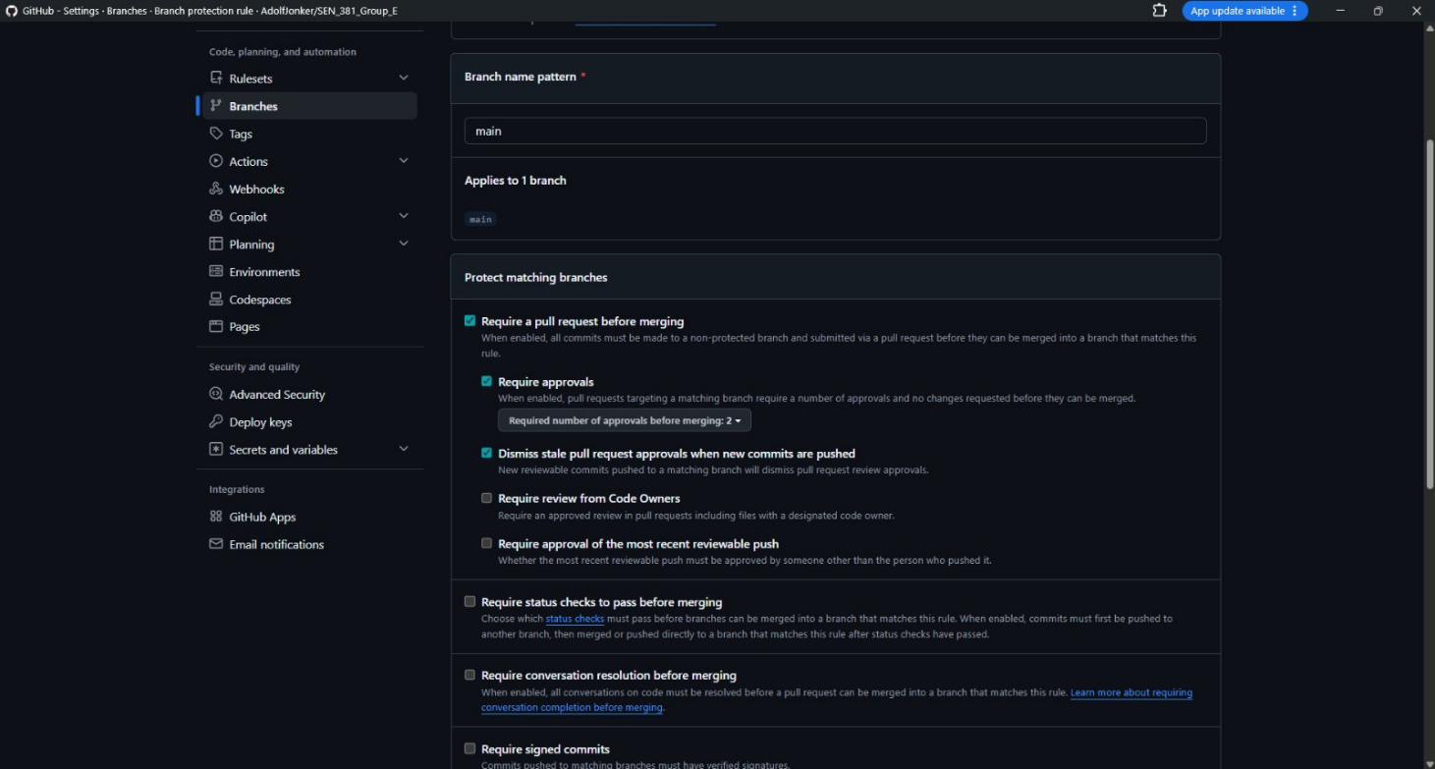

Issues / Project Board
Meaningful engineering work is tracked via the team's GitHub Project board, with tasks moved through Backlog → Ready → In Progress → In Review → Done as work progresses.

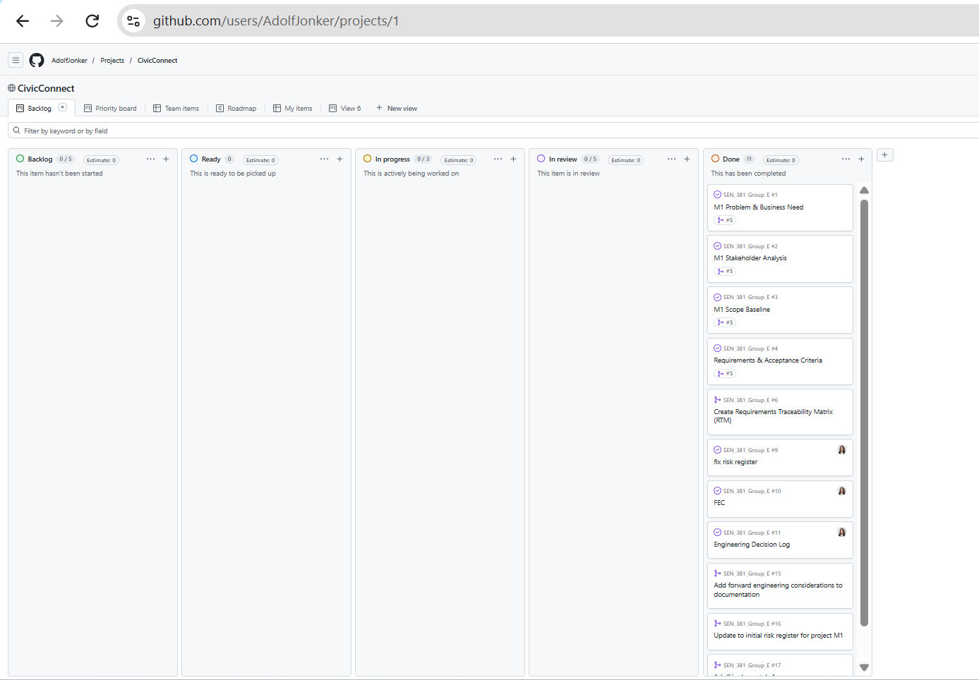

Commit & PR History as Evidence
Repository history shows progressive, dated commits and Pull Requests tied to specific issues (e.g. PR #5, linked to issues #1–#4), demonstrating authentic incremental work rather than reconstructed evidence submitted immediately before assessment.
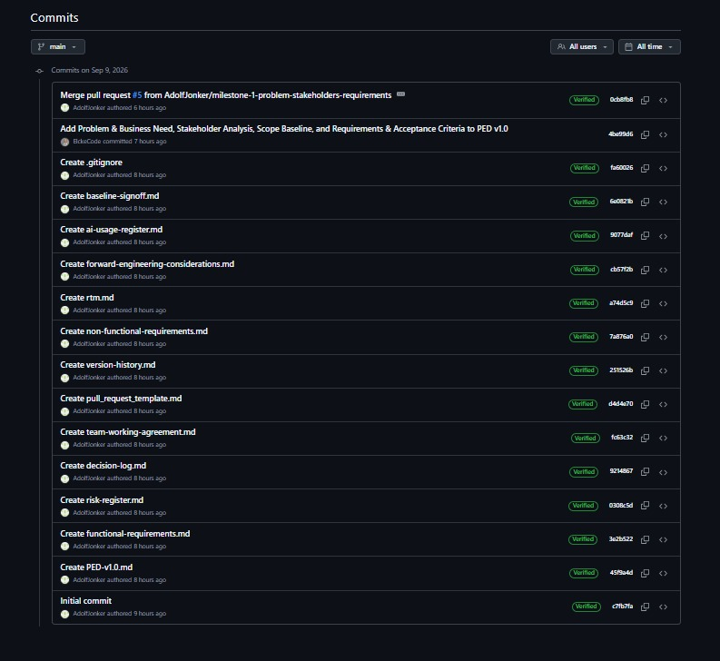

AI Usage Register

Date | Student | Tool | Engineering Task | AI Contribution | Verification | Decision | Issues Found
09/09/  2026 | Donya | Claude | Understanding the M1/Master Brief requirements | Summarised key brief requirements | Summary cross-checked against the actual brief text by myself and two teammates | Accepted | None
09/09/  2026 | Adolf | Claude | Converting Word documents to Markdown; GitHub repo/file structure setup | Produced .md files and a suggested folder structure | Content reviewed by myself and the rest of the team before use | Accepted | None
09/09/  2026 | Elcke | Claude | Learning the Pull Request review/approval workflow | Explained PR review and approval steps | Followed the steps directly on GitHub and confirmed the workflow worked as described | Accepted | None
30/09/  2026 | Donya | Claude | Convert documents to .md.  Understanding the brief requirements | Converted document to .md.  Explained brief requirements | Summary cross-checked against the actual brief text by myself and two teammates | Accepted | .md file conversion was done wrong
30/09/  2026 | Adolf | Claude | Converted documents to .md for Git Hub repository. Used for research purposes and creation of diagrams. Also used for structuring files and assitance in making demo app. | Produced md documents, diagrams and links to websites with useful data. Assisted in demo app creation and UI styling. | Validated that data in the md documents and tables matched researched data. Validated that research links were valid and verified that any code produced was valid and built in the correct way according to the PED. | Accepted | None
30/09/  2026 | Elcke | Claude | Converting Word documents to Markdown files | Produced .md files and a suggested folder structure | Content reviewed before use. | Accepted | None

Milestone 2 — Baseline Review & Initial Design Decisions

M1 Baseline Review — Controlled Change Check
Per Master Brief change-control requirements, the M1 baseline (Requirements FR001–FR013 / NFR001–NFR005, Scope Baseline, Constraints CON001–CON005) was reviewed against the M2 architecture, data and design decisions below. No material changes to the baselined requirements, scope, or constraints were required.
FR009 / status state model — confirmed identical to the ServiceRequest.status enum (Open/Assigned/InProgress/Resolved/Closed) adopted in the M2 Entity Model. No drift.
NFR003 (RBAC) — realised via the Strategy-per-role filtering decision (ADR-DESIGN-002). Consistent with M1 intent; no wording change needed.
NFR004 (immutable audit trail) — realised via the append-only StatusHistory entity and AuditLogObserver (ADR-DESIGN-001). Consistent with M1 intent; no wording change needed.
CON005 (security-shapes-M2-data-model) — M1 explicitly anticipated this; the M2 data model and RBAC decisions fulfil rather than contradict it.
No baseline change records were required for M2. This finding itself is recorded as evidence of a stable, well-scoped M1 baseline per Master Brief §11.

ADR-DESIGN-001: Status Transition Guard + Observer for Audit Logging
Status: Accepted
Context / Problem: ServiceRequest.status must only move through the defined lifecycle (Open → Assigned → InProgress → Resolved → Closed per FR009), and every transition must produce an immutable audit record (NFR004) plus visible feedback to the requester (FR004) without staff needing a separate manual step. Validating that a transition is legal and reacting to a valid transition (writing history, future notifications) are distinct concerns that risk becoming entangled in a single service method.
Alternatives considered (A2 Task 1): Inline validation + inline side effects — simplest, but couples transition logic to every consumer of a status change. State/full State-machine pattern per status — more formally correct but adds a class per state for a fixed, small, linear lifecycle; not justified by CivicConnect’s scope (5 states, no branching).
Decision: Adopt a lookup-table transition guard plus an Observer for side effects, in preference to a full State pattern, since the transition set is small and unlikely to grow. The guard validates legality first; on success it publishes to AuditLogObserver, which writes the StatusHistory row in the same transaction (ADR-DATA-001) and can later fan out to a notification observer for FR004 without changing the guard.
Benefit: Decouples transition legality from transition consequences; new consequences (e.g. a future notification observer) can be added without touching the guard or existing observers. The lookup table is a single, testable source of truth for FR009.
Trade-off/complexity introduced: The Observer adds an extra layer of indirection. This is justified because two observers are registered at M2: AuditLogObserver and StatusVisibilityUpdater. The guard check and the AuditLogObserver write must run inside the same transaction as the optimistic-concurrency check (ADR-DATA-001). This means an audit record is never written for a transition that does not commit. StatusVisibilityUpdater runs only after commit, so a failed notification never rolls back a saved status change.
Affected modules/classes: StatusTransitionGuard (new); ServiceRequestService (status-update method); AuditLogObserver and StatusHistory entity (per Entity Model).
SPOF / architecture note: Keeping the Observer in-process (rather than an external message broker) avoids introducing a second single point of failure (see Section 5.3, Scalability and SPOF Notes); the design allows moving notifications out-of-process later without changing the core status logic.
RTM / implementation evidence: Links to FR009, NFR004, FR004 (RTM-004, RTM-009, RTM-017). Implementation evidence: GitHub board #21 Status Transition Management and #23 In-Process Observer Seam (Issues #21 and #23 are closed).
Evidence: A2 Task 1: Gamma et al. (1995) Observer pattern; Chikkanayakanahalli Ramachandrappa (2024) state-machine management. Project context: FR009, NFR001, NFR004, RISK-007.

ADR-DESIGN-002: Strategy-per-Role RBAC Filtering
Status: Accepted
Context / Problem: NFR003 requires that a requester cannot retrieve another requester’s data, and FR005 requires staff to see only requests relevant to their authorised role. User.role has three values (Requester/Staff/Management), each needing genuinely different filtering behaviour (own requests only; authorised-scope requests; full aggregate view for FR012/FR013). Hardcoded conditional branches work today but risk an accidental cross-role access leak as rules change.
Alternatives considered (A2 Task 1): Simple controlled-list validation — appropriate for input validation (e.g. FR001 category), but does not fit access-control filtering, which must vary query/output behaviour per role rather than validate a fixed value.
Decision: Adopt the Strategy pattern: RequesterFilterStrategy, StaffFilterStrategy and ManagementFilterStrategy each implement a shared FilterStrategy interface. The service layer resolves the correct strategy from User.role and delegates filtering to it, rather than branching on role inline.
Benefit: Each role’s access rule is isolated, testable and independently reviewable, supporting NFR003’s defensibility and mitigating RISK-003 (RBAC implemented incorrectly). Adding a future role means adding a class, not editing existing role logic.
Trade-off / complexity introduced: Three additional classes plus an interface for a fixed, small set of roles. Accepted because RBAC is explicitly security-critical (CON005). The service layer’s role-to-strategy resolution step needs its own test, independent of each strategy’s own filtering test.
Affected modules/classes: FilterStrategy (new interface); RequesterFilterStrategy, StaffFilterStrategy, ManagementFilterStrategy (new); ServiceRequestService (resolves and delegates); User entity (role field drives resolution).
RTM / implementation evidence: Links to NFR003, FR005, FR012, FR013 (RTM-016, RTM-005, RTM-012, RTM-013). Implementation evidence: GitHub board #22 Role-Based Request Filtering (issue #22 has been closed).
Evidence: A2 Task 1: Gamma et al. (1995) Strategy pattern; Martin (2000): open-closed principle; Six et al. (2022) access-control design. Project context: FR005, NFR003, RISK-003, CON004.

Architecturally Significant Requirements and quality drivers
Architecturally significant requirements (ASRs) are the small set of requirements that force the selection of structural components. CivicConnect does not treat every FR/NFR as architectural components but instead the drivers below are the ones that change boundaries, enforcement points and infulence stack selection.
ASR ID | Quality driver | Source requirements / constraints | Why it is architectural | How it shapes M2 decisions
ASR-01 | Authorisation integrity (RBAC) | NFR003, FR005, FR012, FR013, CON005, RISK-003, Cost vs Security trade off | Access rules must sit on a trusted server boundary. A Client-only filtering cannot fully protect against a requester retrieve another requester’s data. Free-tier hosting will not supply enterprise IAM, so enforcement is application-layer. | Strategy per role filtering (ADR-DESIGN-002); Spring Security on API routes; no anonymous data endpoints; package boundary security in the modular monolith (ADR-ARCH-001).
ASR-02 | Audit / accountability integrity | NFR004, FR008, FR009, FR011, CON005, CON004 | Status history must be complete and not editable through normal actions. Audit correctness is a correctness property of the write path, not a reporting add-on. | Append only StatusHistory in the same DB transaction as the status change (ADR-DATA-001 / A2 Task 2 Approach A), AuditLogObserver after a successful guard (ADR-DESIGN-001).
ASR-03 | Controlled lifecycle correctness | FR008, FR009, FR011, RISK-003 (related ownership misuse) | Illegal skips (e.g. Open → Closed) break ownership and accountability. Transition rules must be central and testable. | StatusTransitionGuard lookup table as single source of truth (ADR-DESIGN-001), service-layer enforcement with DB constraints as backstop (A2 Task 2).
ASR-04 | Status visibility without extra staff work | FR004, NFR001, Conflict #2, RISK-007 | Requesters must see updates on next load or within 5 seconds. Freshness rules out stale status caches and remote notification SPOFs for M2. | In-process publish-after-commit Observer (A2 Task 3 + ADR-DESIGN-001), live status read from PostgreSQL; no distributed broker in M2.
ASR-05 | Usable responsive delivery | NFR005, NFR002, FR001–FR003 | Core flows must work at 375px and keep submission ≤6 fields. UI must remain a thin client over the same API used by staff/management. | Separate React 19 + Vite SPA talking to REST/JSON API (ADR-TECH-001), Vite builds static assets; responsive layout stays in the frontend.
ASR-06 | Buildable under free-tier / small-team constraints | CON002; CON003; FEC-003; RISK-005; RISK-006; Schedule/Cost vs Quality/Security trade-off | Architecture and stack must fit three students, no budget, and free hosting limits. Unnecessary distribution increases ops cost without solving a current ASR. | Modular monolith (ADR-ARCH-001) over microservices; single Spring Boot JAR + Vite static frontend; free/OSS licences only (ADR-TECH-001, §5.8).

Measurable expectations used as architecture tests (not a second NFR list):
- ASR-01: unauthenticated or wrong-role API calls to another user’s request must return a 401/403 error this must be verified later in M3 role tests.
- ASR-02 / ASR-03: An illegal transition writes zero status history rows and a legal transition writes request + history together.
- ASR-04: after a commit, the requester status view shows the new status on reload within the NFR001 window without a separate staff notification step.
- ASR-05: Core submission and status-view flows remain operable without horizontal scrolling st a 375px viewport width as per NFR005’s acceptance criteria.
- ASR-06: selected stack runs locally with free tooling and has a plausible free-tier deploy path.
These ASRs close the M1 forward concerns that were waiting on architecture: FEC-001 (authz), FEC-003 (deployment limits), FEC-006 (concurrency model stays single-app + DB), and FEC-007 (layered module structure).

Architecture decision and diagrams

Alternatives compared
Two realistic styles were compared for CivicConnect.
Dimension | Option A — Modular monolith (layered web app) | Option B — Microservices (split API / notification / audit services)
Fit to ASRs | One process can enforce FR009, write NFR004 audit, and publish FR004 visibility in one controlled flow | Network boundaries between status, audit and notification add partial failure modes that threaten ASR-02 and ASR-04
Complexity | Packages/modules inside one deployable; matches three-person team (CON002/CON003) | Multiple services, contracts, CI pipelines, and ops surfaces, not justified by current evidence
Deployment | One backend service + DB (+ static frontend) fits free-tier PaaS | Several always-on services burn free credits and multiply SPOFs
Security boundary | Single trusted application layer for NFR003 | Every service needs authn/authz; larger attack surface for the same FRs
Change cost | New Observer subscriber or Filter Strategy class stays local (ADR-DESIGN-001/002) | Cross-service versioning for every status event
When it would win | Default for CivicConnect’s scoped request lifecycle | Only if audit or notification must leave the local DB/process (outbox / external notifier) — not evidenced now
Decision: adopt Option A modular monolith with clear internal layers. Option B is rejected as disproportionate (rubric: “a more distributed architecture is not automatically more advanced”).
Logical layers (architecture), not deployment tiers:
- Presentation: React 19 + Vite SPA. Requester, Staff and Management views. Vite produces the static build.
- API / interface: Spring Web REST controllers, DTO validation, authentication entry.
- Application / domain services: ServiceRequestService, StatusTransitionGuard, FilterStrategy resolution, Observer publish.
- Persistence: Spring Data JPA repositories, PostgreSQL 17, Flyway migrations.
- Cross-cutting: Spring Security (RBAC), transactional boundaries, structured logging.
Physical deployment tiers remain fewer: browser → HTTPS → application process → managed PostgreSQL.

ADR-ARCH-001: Modular monolith (closes DEC-004)
Status: Proposed → ready for team baseline
Closes: DEC-004 (architecture deferred at M1)

Context / problem:
CivicConnect needs a structure for components, communication and data flow before meaningful construction. M1 correctly deferred this in DEC-004. The ASRs above now exist. Choosing microservices because they were taught would add distribution cost without evidence.

Alternatives considered:
Modular monolith (layered) vs microservices this can be found in the comparison table.
Decision: Modular monolith. This keeps status transition; audit write and in-process status for changed events inside one Spring Boot application. This will Expose a versioned HTTP JSON API to the SPA. It will also Keep module boundaries as packages (api, domain/service, persistence, security) so FEC-007 maintainability is real without network hops.
Consequences:
- Positive: supports ASR-01–ASR-04 with one transaction and one security filter chain, lower ops burden under CON003 and diagrams stay readable for defence.
- Trade-off: the monolith can become a “ball of mud” if package rules are ignored or mitigated by package layout, ADRs, and two-reviewer PRs (DEC-002).
- Later escape hatch: if notification becomes an external service, introduce REST or outbox via a new ADR; do not invent that boundary now (aligns with A2 Task 3).
RTM links: NFR003, NFR004, FR004, FR008, FR009, FR005 (ASR-01–ASR-04).
Related ADRs: ADR-DESIGN-001, ADR-DESIGN-002, ADR-TECH-001, ADR-DATA-001.

Context diagram (C4 Level1)
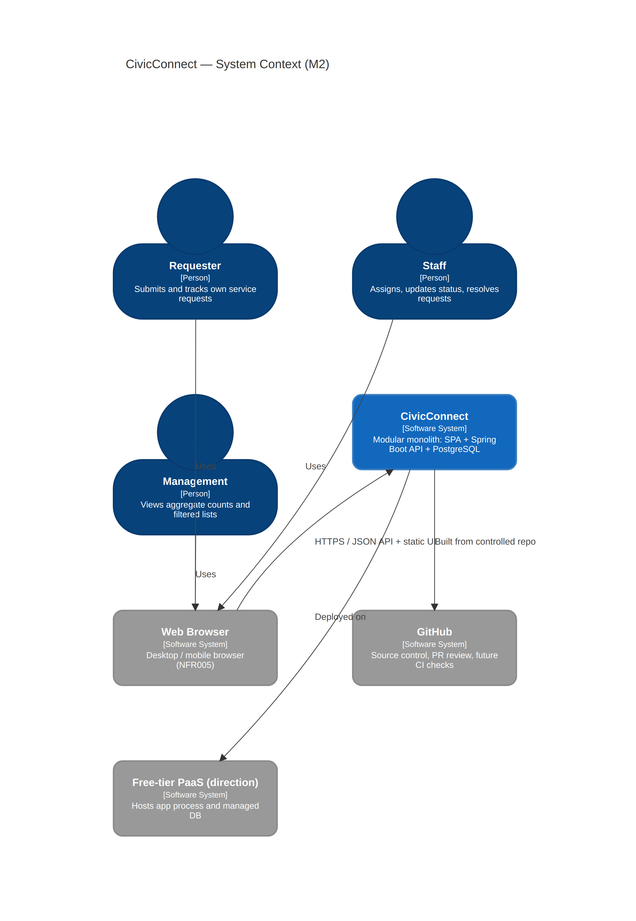

Container / component diagram (C4 Level 2–3)
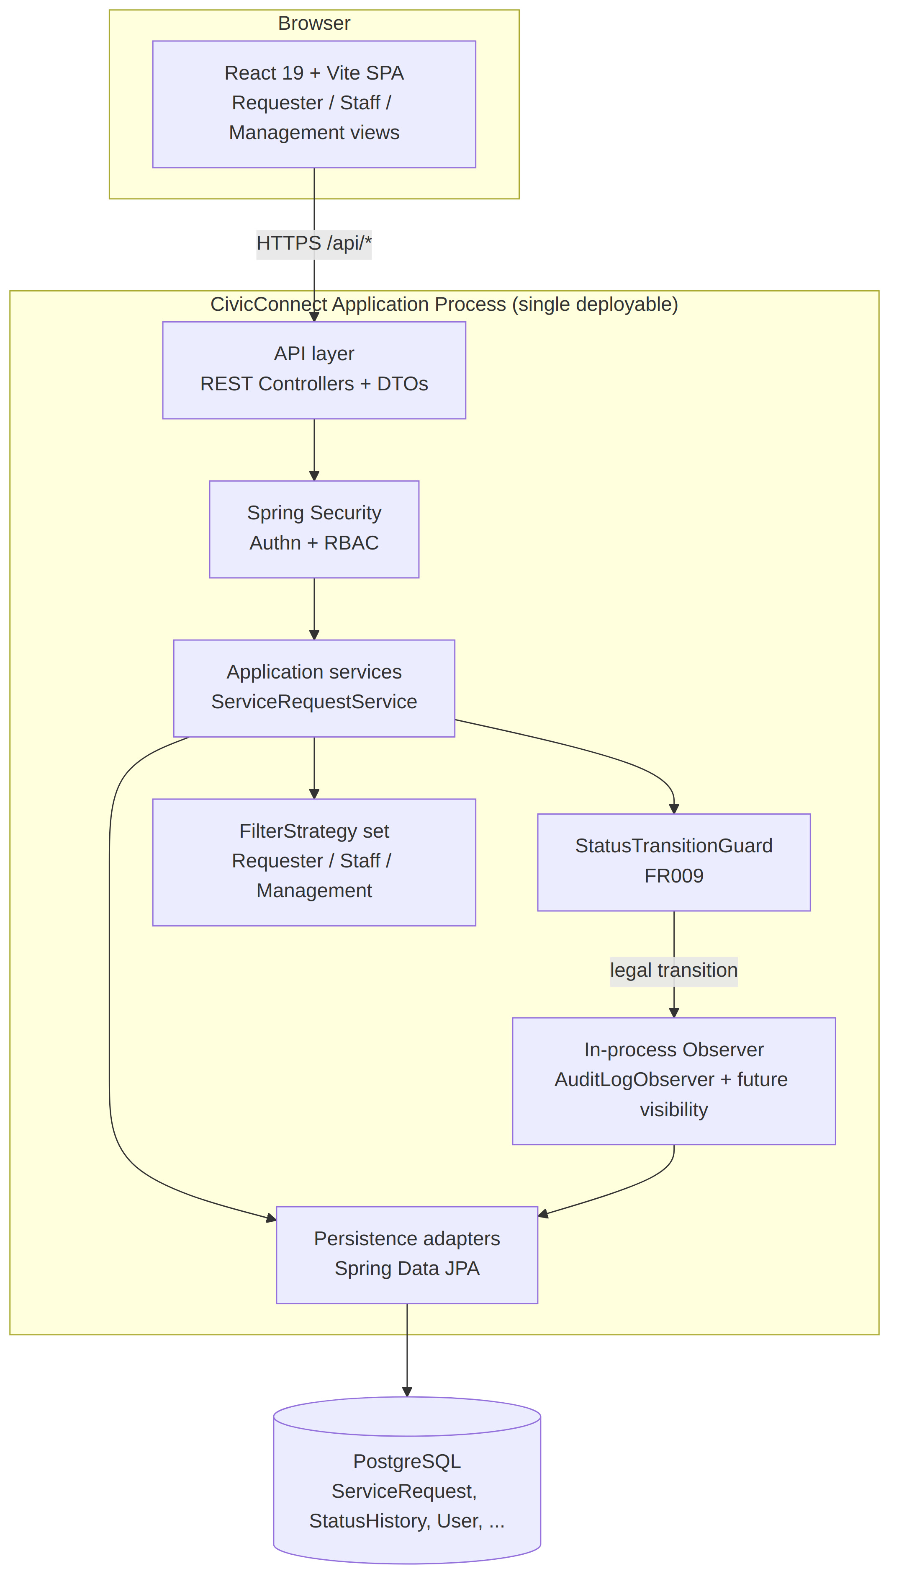

Technology-stack decision

Comparison evidence
Candidate stacks were compared against ASRs, CON003, RISK-005 (learning curve), FEC-003 (hosting) and security needs (CON005).
Criteria | Candidate 1 — Java 25 / Spring Boot 4.1.x + React 19 (Vite) + PostgreSQL 17 (chosen) | Candidate 2 — Node.js / Express + React 19 (Vite) + PostgreSQL 17
ASR-01 RBAC | Spring Security is a mature, documented authz stack for role checks on every route (app-layer, per Cost-vs-Security) | Passport/middleware possible, but team has clearer Java/Spring coursework path for server side enforcement
ASR-02 / ASR-03 transactions | Spring @Transactional and JPA matches A2 Task 2 atomic assign/audit recommendation | Possible with an ORM, but weaker fit to the team’s existing Java persistence teaching
Maintainability (FEC-007) | Clear layered packages; strong typing on the server | Flexible but easier to grow unstructured without discipline
Cost / licensing (CON003) | All core components OSS (see licence table) | Also OSS not a differentiator
Deployment | Executable JAR + Vite static SPA; widely documented on free PaaS | Also deployable; similar free tier constraints
Team capability (RISK-005) | Preferred: Java backend familiarity; React and Vite frontend shared by all | Would force full-stack JS on the server without a clear capability gain
Ecosystem risk | Stay on Spring Boot 4.1.x patch line for the project; minors need planned upgrades | npm dependency churn is higher for a small team to police

Decision: Candidate 1. Recorded as ADR-TECH-001 (closes DEC-003).

Selected stack — versions, licensing, compatibility
Layer | Technology | Intended version baseline | Licence | Compatibility / notes
Runtime | Java (Temurin/OpenJDK) | 25 LTS | GPL Classpath Exception (OpenJDK) | LTS (GA Sep 2025). Spring Boot 4.1 supports Java 17–26; Java 25 is in range — Boot 4.1 system requierments
Backend framework | Spring Boot | 4.1.x (latest 4.1 patch at bootstrap) | Apache License 2.0 | OSS support: minors ≥12 months — Suported versions Pin patch in pom.xml; do not drift majors mid-project without a new ADR
Security | Spring Security (via Boot starter) | Managed by Boot 4.1 BOM | Apache License 2.0 | Enforces ASR-01 on API routes (app-layer RBAC under CON003/CON005)
Persistence API | Spring Data JPA / Hibernate | Managed by Boot BOM | Apache License 2.0 | Maps entities; optimistic @Version for concurrency (A2 Task 2)
DB migrations | Flyway | Managed compatible release | Apache License 2.0 | Schema as code; runs on startup or release command
Database | PostgreSQL | 17 (managed instance) | Postgresql License (permissive, OSI-approved) | ACID transactions for ASR-02; free-tier managed options on PaaS
Local/test DB | H2 (test profile only) | Managed by Boot | MPL 2.0 / EPL | Speeds unit/integration tests; not the production store
Frontend | React | 19.x (pin in package.json) | MIT | SPA for role-specific UIs; responsive layout for NFR005
Bundler / dev server | Vite | 6.x (or current stable Vite pin in package.json) | MIT | Named explicitly: local DX, proxy to Spring API in dev, production static build for ASR-05
Build (backend) | Maven | 3.9+ (Boot 4.1 needs Maven 3.6.3+) | Apache License 2.0 | Wrapper committed so CI/local use the same tool
Build (frontend) | Node.js + npm | Node 22 LTS (or team-confirmed LTS) | Node licence / various | Builds the Vite SPA; not required on the production JVM host if assets are pre-built

Compatibility assumptions:
- Backend Java 25 ↔ Spring Boot 4.1.x is a supported combination (Boot 4.1: Java 17 through 26).
- Spring Data JPA + PostgreSQL 17 driver (org.postgresql) stay BOM-aligned; do not override driver versions casually.
- Frontend (React 19 + Vite) talks only to documented /api routes; Vite dev-server proxy in development; same-origin or reverse-proxy when deployed.
- Secrets (DB URL, JWT/session keys) come from environment variables / PaaS secret store — never committed (Master Brief / DEC-002 repo rules).

ADR-TECH-001: Technology stack (closes DEC-003)
Status: Proposed → ready for team baseline
Closes: DEC-003 (stack deferred at M1)
Context / problem: M1 deferred stack selection until requirements and constraints were stable. RISK-005 warned against choosing tools for interest. CON003 limits the team to free/OSS. ASRs now demand server-side RBAC, transactional audit writes, and a responsive web UI.
Alternatives considered: Spring Boot 4.1.x + React 19 / Vite + PostgreSQL 17 vs Node/Express + React 19 / Vite + PostgreSQL 17 (table above). Other stacks (e.g. .NET, Python/Django) were not shortlisted because they add a new language learning load for no ASR gain.
Decision: Java 25 (LTS), Spring Boot 4.1.x, Spring Security, Spring Data JPA, Flyway, PostgreSQL 17, React 19 + Vite SPA, Maven wrapper.
Consequences:
- Positive: direct fit to ASR-01–ASR-05, licences comply with CON003, matches A2 persistence/API recommendations (local transactions, in-process events, HTTP only at the UI boundary), app-layer RBAC/audit matches the Cost-vs-Security trade-off.
- Trade-off / risks: JVM memory on free tiers is tight (RISK-006), must set heap flags and accept cold starts, Spring Boot 4.x is a newer major line — pin 4.1.x patches and avoid mid-project major jumps without an ADR, frontend and backend are two build toolchains (npm/Vite + Maven) — documented in README.
- Deferred inside this decision: exact PaaS vendor account, production backup vendor, and email/SMS provider (still FEC / future ADR).
Evidence links: Spring Boot 4.1 system requirements / support policy, OpenJDK 25 LTS, PostgreSQL 17 licence page, React and Vite MIT licensing, A2 Tasks 2–3 recommendations, CON003, RISK-005, RISK-006.

Deployment compatibility

Current deployment direction
Item | M2 direction
Environment assumption | Single free/low-cost PaaS direction: Render or Railway (final account selection deferred to M3 staging if needed)
Application packaging | Spring Boot 4.1.x executable JAR; Vite production build of the React 19 SPA served as static files (either from Spring classpath/static or a paired static site on the same platform)
Data store | Managed PostgreSQL 17 on the same platform family (or platform Postgres add-on)
What is deliberately not done in M2 | Production cut-over, multi-region HA, full observability stack, paid tiers, custom domains as a mark requirement

This satisfies FEC-003’s need for a plausible environment without pretending M2 is production operations.

Compatibility with architecture and stack
Decision | Compatible with direction? | Notes
Modular monolith (ADR-ARCH-001) | Yes | One web service and one database matches free-tier service limits
Spring Boot 4.1.x JAR (ADR-TECH-001) | Yes with care | Free instances often ≤512 MB RAM and avoid unused actuators in free tier
PostgreSQL 17 | Yes | Managed Postgres available on common free/low-cost PaaS; confirm retention/expiry rules (some free DBs expire, RISK-006)
In-process Observer | Yes | No extra broker service to fund or babysit
React 19 + Vite static build | Yes | Vite output is static hosting–friendly or embed in JAR for one artefact

Configuration, secrets, persistence, networking
- Config: application.yml + profile-specific overrides (dev, staging). No secrets in Git.
- Secrets: SPRING_DATASOURCE_URL, username/password, and session/JWT secret supplied by PaaS env vars.
- Persistence/state: Database is the system of record. App instances are treated as disposable. Flyway migrations are the schema path.
- Networking: Public HTTPS to the app, database not publicly writable from the internet if the platform allows private networking. Browser only calls /api/...
- CORS / cookies: Dev may use Vite proxy, deployed direction prefers same-site or explicit allowed origins.

Architecture, Technology & Initial Design Baseline — Sign-off(M2)
Field | Value
Project | CivicConnect
Baseline Type | Milestone 2 — Architecture, Technology & Initial Design Baseline
Document version | PED v2.0
Date | 30/09/2026
Included | ASR-01–06; ADR-ARCH-001; Entity model + ADR-DATA-001; ADR-TECH-001; ADR-DESIGN-001; ADR-DESIGN-002; ADR-INT-001; deployment direction; RTM Design Ref (M2) as populated
Open / future scope | Exact PaaS account; production backup vendor; external email/SMS; mature CI/CD; full automated tests; advanced analytics (M1 defended exclusion); any material change to FR/NFR baseline
M1 change records | Evolved RTM, Added Risks to Risk-Register
Outcome | ACCEPTED as development baseline for controlled construction
Field | Value

Team Sign-off (M2)
Name | Role / contribution this version | Confirmation | Date
Elcke Van Der Berg | PED/RTM continuity, design-pattern ADRs | Confirmed | 30/09/2026
Adolf Jonker | Data/persistence, technology stack | Confirmed | 30/09/2026
Donya Pretorius | ASRs/architecture, GitHub/CI evidence | Confirmed | 30/09/2026

Historical M1 Baseline Sign-off
Field | Value
Baseline Type | Milestone 1 — Engineering Foundation & Requirements Baseline
Version / Date | v1.0 / 09/09/2026
Outcome | ACCEPTED
Signatorie | Elcke Van Der Berg; Adolf Jonker; Donya Pretorius — Confirmed 09/09/2026

Bibliography
Aglibar, K. D. M. et al., 2022. Ticketing System: A Descriptive Research on the Use of Ticketing System for Project Management and Issue Tracking in IT Companies. International Journal of Computing Sciences Research, Volume 7, pp. 1066-1075.
Li, W., Zhou, Y., Luo, S. & Dong, Y., 2022. Design Factors to Improve the Consistency and Sustainable User Experience of Responsive Interface Design. Sustainability, 14(15), p. 9131.
Mucha, J., Kaufmann, A. & Riehle, D., 2024. A systematic literature review of pre-requirements specification traceability. Requirements Engineering, Volume 29, pp. 119-141.
Sandhu, R., Ferraiolo, D. & Kuhn, R., 2000. The NIST model for role-based access control: Towards a unified standard. In: Proceedings of the Fifth ACM Workshop on Role-Based Access Control. Berlin, ACM.
Smolle, M.-T., 2025. From Request to Delivery – Innovative Process Design for IT Demand and Portfolio Management at STRABAG, Vienna: s.n.

